Evaluation Report - Sharing Hope 2024-25
A Creative Wellbeing Project for Staff of Swansea Bay University Health Board

14th January 2026

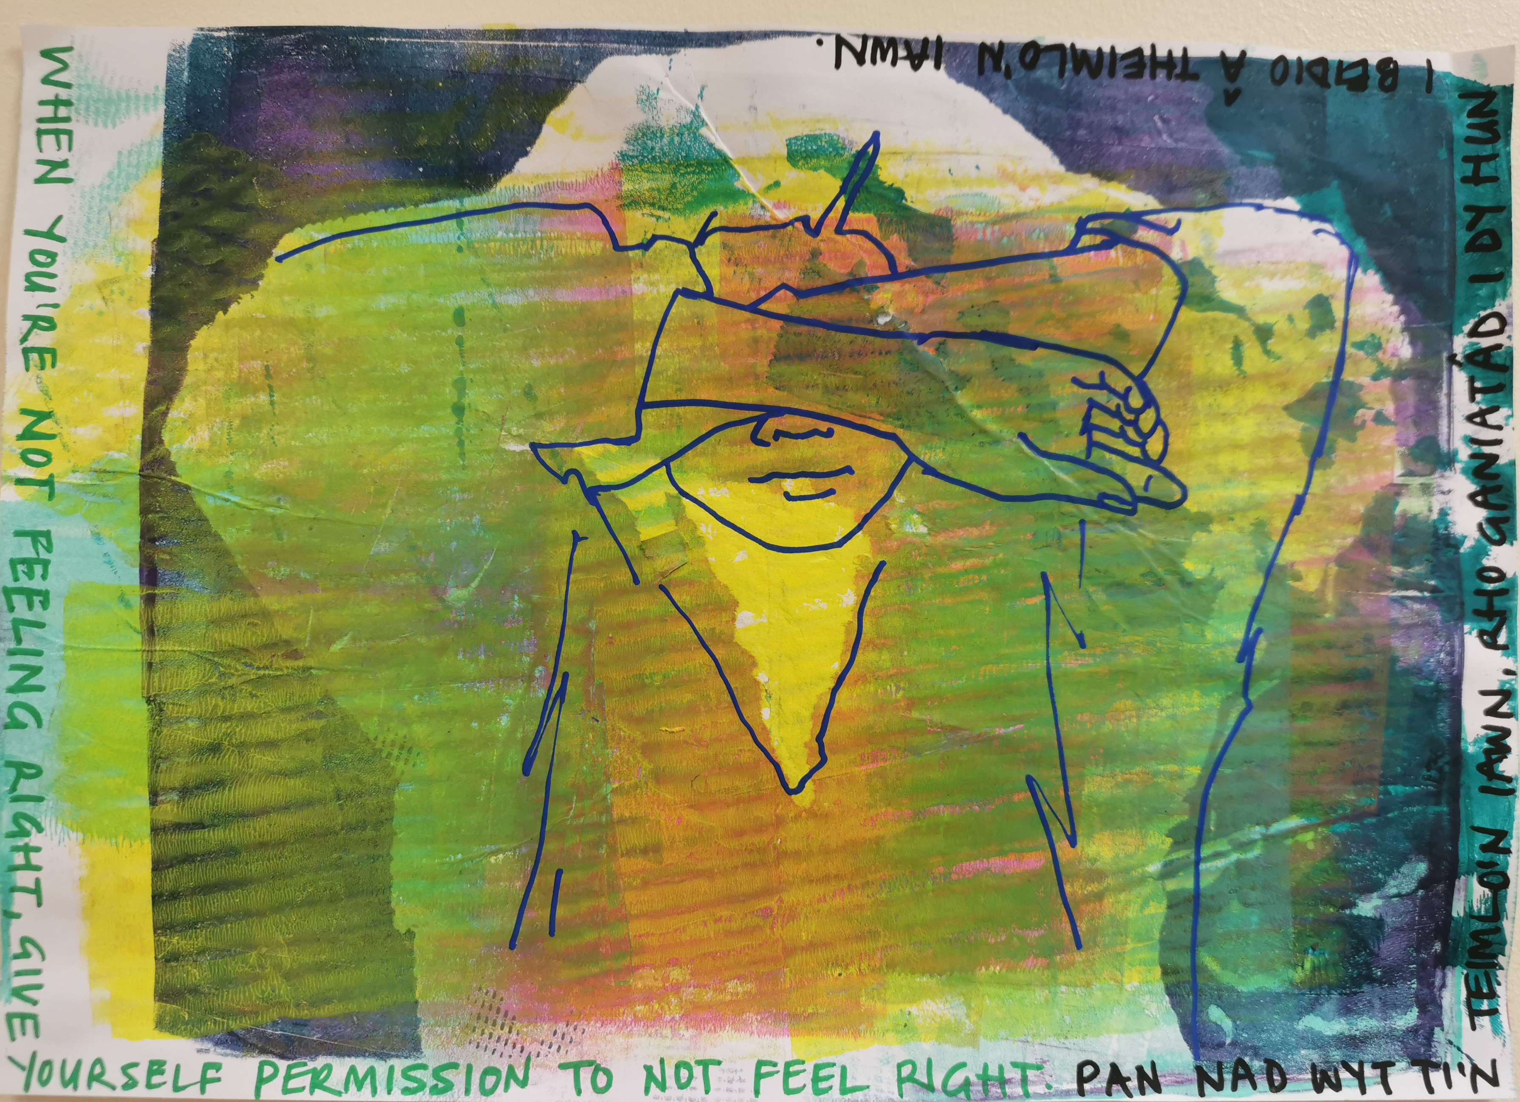

just a lovely pause in a stressful week

Partners
Morlas CYF, an arts organisation with a creative health focus
Arts & Heritage team, Swansea Bay University Health Board

Funders
Arts, Health and Wellbeing Lottery funding from Arts Council of Wales
Swansea Bay Health Charity

Table of Contents
Executive Summary 3
1. Introduction 5
1.1 Background 5
1.2 Project Overview 5
1.3 Evaluation Framework 6
2. Project Approach 7
3. Findings 9
3.1 Benefits reported by participants 9
3.2 Good Practice Points 9
3.3 Successes 10
3.4 Challenges and Operational Barriers 10
4. Project Learning and Recommendations 11
Quotes and Compliments 12
References 13

Executive Summary
Sharing Hope 2024-25 was a staff wellbeing project for clinical and non-clinical staff working in Swansea Bay University Health Board (SBUHB), delivered by Art Partner Morlas, a new creative health arts company, in collaboration with the SBUHB Arts and Heritage team. It aimed to build on SBUHB’s 2021-24 award-winning initiative, with the aim of widening access and increasing impact, towards reducing staff absence due to poor mental health. It was supported by Arts Council of Wales lottery funding and Swansea Bay Health Charity.

The mixed-methods evaluation drew on quantitative and qualitative data gathered by Morlas during project sessions and post project structured interviews with each member of the delivery team conducted by the evaluator. It explored participant experience and barriers to implementation.

Key Findings

- High-quality, artist-led creative activities in a drop-in format offered accessible, safe, restorative spaces for SBUHB staff
- Strong positive benefits reported by staff included relaxation, connection, and a tangible lift in mood and resilience
- Good Practice included psychologically safe co-facilitation working with expert practitioners; good instrumental and affective support for participating freelance artists including debriefs; specialist materials, equipment and skills; SBUHB liaison from Arts & Heritage team
- Primary Operational barriers within SBUHB including line-manager permission, room availability, scheduling at busy, peak periods combined with the multi-site, multi-artform approach resulted in patchy attendance. Insufficient momentum built at successive locations meaning participant numbers were low and few staff returned for multiple sessions
- Secondary Operational Barriers art partner Morlas was a new and small arts company. Its two person team, both with relevant expertise and experience, undertook both project management and delivery. This presented significant project delivery and personal wellbeing risks. A well-intentioned, rushed project commencement meant that there was no opportunity to embed a co-production approach to planning, project design, delivery and evaluation which may have reduced frictions and improved momentum
- Continued appetite for creative approaches to staff wellbeing at a senior level, has been cemented by the previous successes of the project, and supported at staff level by the launch of the online Swansea Bay Creative Community

Recommendations

- Partnerships with well-resourced, established Arts organisations, enabling clear separation of project design, management and delivery responsibilities would minimise risks, enhance project resilience, and embed the ethos of a creative health programme by better supporting whole team wellbeing
- Co-production should be embedded into all programmes, including those that have been previously tested, because contexts change particularly at a time of multiple crises within NHS Wales and the wider world. It would benefit planning, team cohesion and culture, engagement and participation, alignment of delivery methodologies and enhance evaluation.
- Project delivery could be enhanced by longer planning cycles. Budgeting and planning for whole delivery team training events would embed co-production and evaluation methodologies before activity begins and minimise safeguarding, data protection and other project risks
- To strengthen a sense of community and ensure successful creative approaches to staff wellbeing, SBUHB needs more champions within middle management. Future holistic approaches, that encompass all staff and service users, could test staff referral pathways if it wishes to address staff retention and absences
- Supervision offer, if made, should be separate and independent from the delivery team to enhance confidentiality, choice and minimise 'courtesy bias'
- a clearly articulated vision and community of practice within project delivery teams to articulate and clarify differences between psychotherapeutic and arts practice based approaches would strengthen delivery and impact
- To enhance evaluation and measure impact, robust data collection tools should be embedded into project delivery models, with co-production, training and support for the delivery team undertaken before project commencement. Without this, it is not possible to understand ROI or impact on staff retention and absence.
- To ensure value is placed on inclusion, planning and training, budget lines are recommended that allow for personal access costs, training and whole team meetings.

1. Introduction

1.1 Background
Swansea Bay University Health Boards' Sharing Hope model of staff wellbeing sessions, embedded within the working day at the hospital settings where they worked, originally began in 2021 within the post-Pandemic context, and won three awards for its work across 2021-24.

This new iteration built on the existing model to create a multi-site, multi-artform programme, aiming to increase impact through a framework which unfolded across five different SBUHB hospitals from November 2024 to October 2025, in six blocks of weekly lunchtime sessions, each led by different artists, offering five different artforms: textiles; ceramics; creative writing; movement; ‘gelli’ printing.

SBUHB staff who took part experienced positive impact on their well-being. The sessions provided a creative outlet that was therapeutic and nurtured a sense of community with their colleagues. Staff particularly valued the opportunity to step away from stressful, busy, work situations with recurring themes of relaxation, gratitude, creativity, and mental health support. The sessions were seen as a valuable break from stress, fostering both personal well-being and social connection.

The Sharing Hope 2024-25 evaluation was commissioned by Morlas CYF during project delivery and
undertaken by creative health consultant Justine Wheatley.

1.2 Project Overview
Delivery overview
Delivery of this iteration of Sharing Hope began in November 2024, in a compassionate attempt to address SBUHB staff distress and poor wellbeing at a busy period, and hoping to build on the existing successes and model. Morlas was a new company, comprising two highly experienced professionals with relevant expertise, but the extension of locations and artforms, whilst providing project services that included design, planning, management and sessional delivery, was beyond reasonable capacity, and meant there was no clear separation of responsibilities. The rush to start meant that project planning and training processes did not take place.

The additional challenge of considerable SBUHB operational barriers (increasing patient numbers, financial pressures and staff absences) contributed to sparse single figure sessional attendances, which totalled 127 across the project. A further 60 participant attendances were recorded at two training sessions delivered at the project end in October 2025

Valiant efforts across the whole delivery team, including a project pause in February, helped to build momentum for pottery at Cefn Coed Hospital in March and April 2025 which also had the advantage of a dedicated room and outdoor space. The decision to extend the delivery of 'Print and Pause' sessions at Neath Port Talbot Hospital into a second block demonstrated that 'word of mouth' communication and consistency of delivery could have a positive impact on uptake.

The positive impacts reported by participating SBUBH staff, and noted by the delivery team, reflected multiple good practice points including: a strong creative offer; expert practitioners and specialist materials, techniques and equipment; instrumental and affective support for the artist team; psychologically safe co-facilitation; SBUHB liaison and support. Protocols for co-facilitation that created clear boundaries between art practice and psychotherapy, and independent supervision arrangements would have enhanced delivery.

Legacy
‘It rehumanises us and gives us a break’
Sharing Hope leaves a positive legacy for hundreds of SBUHB staff who took part from 2021, and an appetite at senior levels for creative approaches to workplace wellbeing. A related development is the growing Swansea Bay Creative Community, an online NHS Wales intranet platform, for SBUHB staff to connect and reach out, where Sharing Hope content attracts multiple views. Future staff wellbeing initiatives are likely to be integrated into holistic creative hospital services serving users and staff

Context
Swansea Bay University Health Board (SBUHB) serves a population of around 500,000 people across Swansea and Neath Port Talbot, providing a broad range of NHS Wales healthcare services, from acute care to community services. It has over 14,000 staff and manages a budget of £1.4 billion. Its key sites include three major hospitals: Morriston Hospital (750 beds), which includes the Welsh centre for burns and plastic surgery and one of two cardiac surgery services in Wales; Singleton Hospital (550 beds), which includes a regional consultant-led maternity unit and neonatal intensive care; Neath Port Talbot (220 beds) which includes a minor injuries, elderly care and clinics. Gorseinon Hospital has a focus on older people and Cefn Coed hospital is a mental health facility. It has strong ties to Swansea University, supporting research and training.

The Health Challenge
Over 10,000 working days per month are lost due to sickness in SBUHB, with 30-40% reported as mental-health and occupational stress related absences, negatively impacting productivity, workload, staff retention, recruitment and patient care, and increasing existing financial pressures ( > £78m was spent on temporary staff in 2023). The wide body of research and evidence of the positive impact of art on mental wellbeing, includes increasing examples of the positive impact of creative health workplace interventions. In Wales, SBUHB’s Sharing Hope programme in 2021-24 had further demonstrated the powerful role that arts can play in supporting staff wellbeing.

This iteration grew from a wish to widen access, locations as well as artform. Hence, the programme was designed to run across multiple hospital locations, addressing specific needs of isolated staff cohorts including so-called ‘OSCE’ nurses, who were recruited from overseas in the post-Covid context. Having had a visual arts focus in 2021-24, the new proposed programme also included 3d visual arts as well as movement, creative writing and (originally) songwriting.

The positive benefits experienced by staff taking part align with Wales policy and evidence
recognising creative health as a contributor to NHS Wales staff wellbeing and organisational culture, as recognised in the Memorandum of Understanding between Arts Council of Wales and Welsh NHS Confederation

1.3 Evaluation Framework
The evaluation took a mixed-methods approach, gathering quantitative attendance data, and qualitative feedback from staff focusing on their sessional experience and its impact on their wellbeing. Following the project’s conclusion, one to one structured reflective interviews with each member of the delivery team were undertaken with the independent evaluator (Justine Wheatley), exploring project processes, good practice, challenges and next steps, as well as recording positive impact for those taking part.

2. Project Approach
Outputs
Sharing Hope delivered 46 weekly ‘drop-in’ lunchtime workshops of 2 hours plus, between November 2024 and October 2025 at five SBUHB hospital sites reaching 177 staff. Numbers attending were a maximum of eight SBUHB staff members, other than in two special team events (printmaking, movement) where there were around 30 people in attendance at each session. There was a focused engagement and communication campaign throughout, deploying presentations, intranet messages, posters and social media.

Programme Design
Singleton Hospital 8 x Textile sessions in November and December 2024
Cefn Coed Hospital 8 x Ceramic sessions across January, March and April 2025
Gorseinon Hospital 4 x Movement sessions, in April 2025
Morriston Hospital 8 x Creative Writing sessions in May and June 2025
Neath Port Talbot 16 x ‘Print & Pause’ sessions in June to October 2025

Delivery Team
Morlas Associates:
Morlas CYF was formed in Autumn 2024, and this was its first project. Rhian Jones was responsible for operational project management and also acted as lead textile artist for the first block of sessions at Singleton Hospital. Gini Hearth (GH) undertook project design, co-facilitated all the sessions with the lead artists, and offered supervision to artists if requested. Gini had extensive experience as a facilitator for Sharing Hope across 2021-24, and was therefore recognised in some SBUHB settings, which contributed positively to engagement and confidence amongst NHS staff.

SBUHB Arts & Heritage Team:
Johan Skre, Arts in Health Service Manager, supported throughout, including attending initial sessions for each block to support transition (johan.skre@wales.nhs.uk)

Lead Artists
A different artform led by specialist practitioners was offered at each location.GH co-facilitated, and took over four creative writing sessions, when Rufus Mufasa had to step away for personal reasons

Rhian Jones, Textiles at Singleton Hospital
Esther Ley, Ceramics at Cefn Coed Hospital
C J Ashen, Movement at Gorseinon Hospital
Rufus Mufasa, Creative Writing at Morriston Hospital
Ami Marsden, printmaking at Neath Port Talbot Hospital

Budget
Activities were delivered within the £45,990 budget, of which 65% was expended on artists and materials. There were no specific budget lines for training or personal access needs.
Data Sources and Evaluation Methodology
Independent evaluator Justine Wheatley undertook transcription and analysis of participant feedback, conducted reflective interviews with project personnel and synthesised data for reporting. Data sources included:
- Attendance log
- audio transcriptions of 1:1 interviews between the co-facilitator Gini Hearth and participants
- written comments from SBUHB staff attending sessions (affording greater anonymity)
- Structured 1:1 interviews between evaluator Justine Wheatley and each delivery team members reflecting on strengths, barriers, planning, lessons, and site-specific observations across the six sessional blocks
- Staff who took part in ‘Print and Pause sessions, recorded thoughts and experiences on their gelli-print artworks, and these were documented on film by the team
- Wales and UK based research

3. Findings

3.1 Benefits reported by participants
- Relaxation and Stress Relief - Participants reported feeling calm, relaxed, and refreshed. Sessions provided a mental “pause” from high-pressure work environments, enabling staff to return to duties with improved focus and productivity.

- Social Connection - Opportunities to interact with like-minded colleagues were highly valued and fostered positive team morale; those experiencing isolation due to remote working or shift patterns reported reduced isolation

- Creativity and Self-Expression - Staff appreciated the chance to explore creativity, learn new skills, and express themselves through art. Activities were described as immersive and therapeutic.

- Mental Health Support - participants highlighted significant positive impacts on mental health, with some describing sessions as a “huge boost” during challenging time

- Sense of Achievement - tangible creative outcomes, and the acquisition of new skills contributed to feelings of pride, accomplishment, and personal growth

- Psychological Safety – drop-in format felt “safe” and “supported”; apprehension was eased by facilitator support

3.2 Good Practice Points

- Psychologically safe co-facilitation that normalised mistakes and enabled gentle conversation away from clinical stressor, with Morlas Associate providing support for both participants and freelance practitioners.
- Accessible artforms (visual arts, gelli-printing) and ‘drop-in’ options offering flexible access to staff, aligning with Sharing Hope recommendations (Jones, Mark; Higher Plain Research & Education). Artworks gave satisfying creative results.
- Debriefing & reflection for artists and managers to iterate content and logistics. Practitioners appreciated the two-person delivery model, and this is good practice for safeguarding and wellbeing support for everyone taking part. Practitioners were able to request supervision if they wished;
- Paid planning and evaluation time ensured both instrumental and affective support for freelance artists in line with best practice models for practitioner wellbeing (Naismith, n.d.)
- SBUHB Liaison through the involvement and presence of the SBUHB Arts in Health Service Manager, ensured smooth transitions between the different sites and brokered communications between the arts partner and SBUHB locations, staff and management.
- Expert, experience arts practitioners leading sessional blocks of arts activity, to offer high quality and specialist skills, techniques, materials and equipment for inspiration, enjoyment and skills development.

3.3 Successes
Although attendance was patchy, there were some notable achievements for the project:

- High-impact artforms Gelli printing ‘Print and Pause’ sessions at Neath Port Talbot (NPT) Hospital generated momentum through ‘word of mouth’ and were extended for a second block. Ceramics sessions at Cefn Coed Hospital also gained traction.
- Publicity & Reach a campaign of print, social media and intranet communications, including inclusion of Sharing Hope sessional provision in the SBUHB staff wellbeing 2024-25 calendar. Swansea Bay Creative Community also increased visibility through sharing content, including >8600 views for Raku Firing at Coed Cefn Hospital in April 2025.
- Co-facilitation wins participant and artist feedback demonstrated that planned collaboration supported delivery and participant confidence in some sessions
- Award-winning profile recognition (RSPH, Nursing Times, HPMA Cymru) and increased engagement has cemented an appetite within SBUHB senior management for creative approaches to workplace wellbeing, addressing recommendations from previous Sharing Hope programmes (Jones, Mark; Higher Plain Research & Education)
- Swansea Bay Creative Community launch a new online NHS Wales intranet platform, is nurturing a greater sense of community in line with recommendations

3.4 Challenges and Operational Barriers
Despite SBUHB management support and widely, increased, dissemination of communications, sessions were sparsely attended and momentum did not build. Intersecting barriers that presented challenges to staff participation included:

- Changed NHS Wales context compared to the post-Covid context of project delivery between 2021-24, SBUHB was facing a context of scarce resources of time and money, meaning increasing financial pressures, patient numbers and staff absence rates. This presented considerable challenges to staff participation within hard-pressed hospital settings

- Changed Staffing Cohorts. The ‘OSCE’ cohorts of overseas nurses that had been identified as a target for support during planning, due to the isolation they were experiencing from their families, and within local Swansea communities, had dispersed across multiple sites and recruitment practices had changes, making targeted work with them unachievable

- Permission / Time Staff needed line-manager approval; workload and team loyalty limited attendance. Even short breaks were difficult, and referral pathways failed to establish

- Venues and Logistics double-booked or repurposed venues impacted delivery; some staff struggled to reach sessions in their lunchtimes and the multi-site model combined with a multi-artform project, meant that momentum did not build
- Untested Artforms and locations low return-visit rates are most likely attributable to work pressures, but reflective interviews also noted limited appetite for untested artforms, particularly movement
- Delivery model Morlas was a small, new and untested arts organisation. Its two directors had relevant expertise but lacked capacity or separation of responsibilities across project management and delivery. Their co-facilitation delivery model - arts practitioners working alongside an arts therapist with community arts skills - had positive benefits but needed clearer planning and articulation

4. Project Learning and Recommendations

- Training and induction for the delivery team before commencement of sessional delivery, as recommended for 2021-24 delivery in Sharing Hope Evaluation, for (Jones, Mark; Higher Plain Research & Education), would enhance smooth running of the project and align co-facilitation across therapeutic talk-led vs art practice led approaches.
- Increased planning time the first sessional block of Sharing Hope attempted to address staff wellbeing in the high pressure, busy run-up to Christmas 2024, at the expense of planning, training and testing before project delivery commenced.
- Co-production could have improved project design, as well as the planning and delivery of sessional activities. Freelance practitioners noted a difference of approach between themselves and the co-facilitator; both offered benefits but synthesising and streamlining activities would ensure consistency and enhance experience for those taking part.
- Independent supervision offered from a source outside the delivery team, who were also the practitioner’s employers and managers for the project, is recommended and is best practice for practitioner wellbeing. Independent supervision preserves confidentiality and promotes open dialogue whilst supporting trusted relationships between the art partner and their contracted artists.
- Anonymised evaluation tools, particularly ones that are not face to face, prevent social desirability or courtesy bias, enabling participants to honestly and objectively reflect on their experience and typically eliciting richer responses to better inform understanding of impact, and to plan services that meet user needs. Introduction of written feedback ‘post-it’ notes improved data collection, and were preferable to oral interviews undertaken at the end of sessions.
- Robust Quantative Data Collection tools that offered participants the opportunity to securely and anonymously record their personal and contact information, if desired, would have given more data for analysis about the diversity, roles, characteristics, ages and interests, of those attending whilst potentially enabling more tailored communications to increase engagement, and follow-up surveys to understand impact. It would also have offered opportunities to record and meet specific access requirements for participants and delivery staff.
- Embedded creative health in staff wellbeing frameworks, would create consistent, stronger referral pathways and ensure embedded governance to support staff beyond time-limited initiatives and linking to occupational health.
- Art Partner organisations of a size and scale that is more consistent with SBUHB would offer greater resilience and separation of duties.
- Delivery model clear boundaries between art practice and psychotherapy, with a clearer protocol for cofacilitation and a continued flexible approach to scheduling and access would enhance project delivery and reduce frictions
- Time Pressure to begin delivery, and ensure continuity, impacted the project in several ways, including budgeting processes. Future staff wellbeing project planning would be strengthened by inclusion of specific budget lines for training, personal access requirements and whole team meetings which ensures that time and value are placed on these processes.

Quotes and Compliments

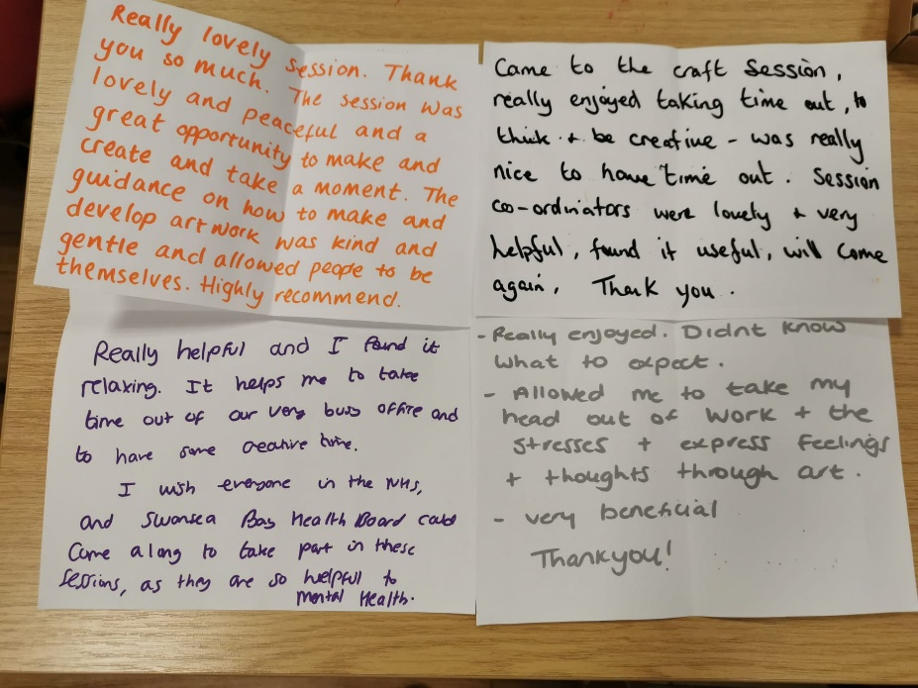

I really, really did appreciate today because it wasn’t just about the art, it was also about being able to interact with like-minded people too

it's just given time out from a busy schedule, so it just relaxes you in order to maybe be more productive ….been nice actually to talk with fellow colleagues as well

I felt calm during my session and my mind was taken away from the stress of the ward

It was great to set time aside for myself and to be creative

Thank you for the opportunity to enter my flow state and take some creative time out

References
Arts Council of Wales – Arts, Health and Wellbeing (MoU & programme updates): arts.wales/our-impact/widening-our-engagement/arts-health-and-wellbeing
Welsh NHS Confederation – Advancing arts, health and wellbeing (MoU brief): nhsconfed.org/publications/advancing-arts-health-and-wellbeing
NHS Wales briefing – Arts for Health and Wellbeing: nhsconfed.org/system/files/media/Arts-for-Health-and-Wellbeing.pdf
SBUHB Sharing HOPE – project communications & awards:
Creative project supporting the mental well-being of NHS staff to continue
Staff express themselves through art to boost mental health and wellbeing
Staff get creative and reflect on pandemic experiences
Arts-based staff wellbeing project wins another national award
WHO Europe scoping review (3,000+ studies) evidencing arts’ role across prevention, promotion, and treatment and supporting the adoption of creative health inside NHS Wales workforce plans HEN Synthesis Report 67 (Fancourt & Finn, 2019): WHO landing page | Direct PDF
WAHWN – Wales Arts Health & Wellbeing Network (sector support): wahwn.cymru

Justine Wheatley, 14 January 2026
E: jehwheatley@gmail.com
M: 07533 376605

