Wales Arts Health and Well-being Network for January 2020

Title: Live Music Now case study on the impact of live music in social care and care homes

Sub title: Health & wellbeing benefits for residents, staff, and setting at Woffington House

200 char: A study on the impact of live music activities delivered by LMN Wales musicians on the health and wellbeing of the residents, staff and setting at Woffinton House, Tredegar between 2016-2019

150 Word: A case study on the impact of live music activities on the health and wellbeing of residents, staff and setting at Woffington House care home, Tredegar, Wales. The programme was delivered in the care home between 2016 - 2019 by early career professional musicians, trained by Live Music Now (LMN).

Initially, the study sets out the context of the Wales wide reach of LMN Wales and draws on previous research, carried out by LMN and partners, into the impact of live music in social care and care homes.

It defines the activities in the programme at Woffington House delivered by the musicians; presents the feedback we have received from staff at the care home on how this affected residents, the staff and setting; and details the impact on the wellbeing of an individual resident who was especially impacted by engagement in live music.

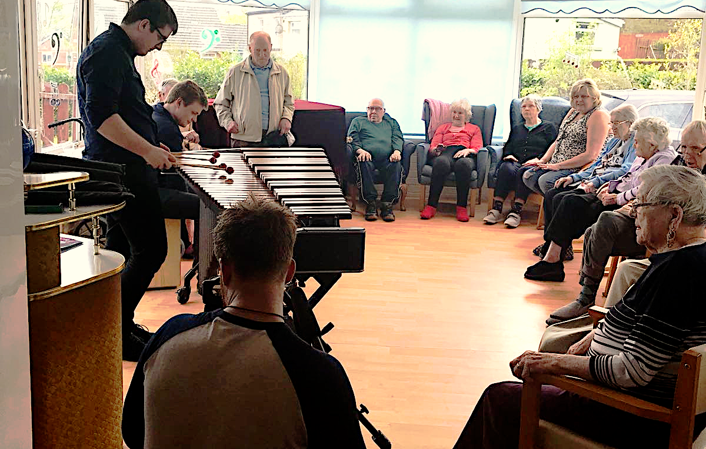

This case study, prepared by Live Music Now (LMN), focuses on a programme of live music activities and their impact on the residents, staff and setting of Woffington House in Tredegar, Wales. The activities were delivered by trained early career professional musicians between 2016-2019. The study aims to illustrate:
- the range and reach of our programme in Wales
- the strategic link into the wider the wider LMN national programme and music in adult social care (ASC)
- how this impacts on people who live and work in a particular care home that we have worked in over an extended period.

Background on LMN and LMN Wales

LMN was created by Ian Stoutzker and Yehudi Menuhin in 1977. It is now chaired by Sir Vernon Ellis. Each year, the charity trains and supports around 400 professional musicians to deliver thousands of evidence-based music workshops around the UK specialising within music and dementia as well as music and special needs. Their training is led by leading researchers, mentors and practitioners.

LMN has been working in Wales since 1990, where we have delivered 350-500 performances a year totalling over 8,000. We are an Arts Council of Wales portfolio organisation and are proud to be the only national arts charity working in all 22 Welsh counties. During the 2016-2019 period LMN musicians visited each of these, reaching 7,440 people in 96 care homes with over 371 performances.

Statistics of the impact of our work with older people

LMN’s evaluation system for care staff focuses on improvements in “mood” (including smiling, laughter, singing, conducting, feet or finger tapping and dancing) and “engagement” (including looking up, making eye contact, speaking and communicating more) as outcomes for participants. The feedback surveys from staff in care homes in Wales 2017-2019 showed that:
- 100 % of settings reported a positive mood response from the participants, to the performers
- 80% reported an improvement in mood in the participants during the sessions, and 85% reported an improvement in mood after the session.
- 93% reported engagement with the performance and musicians
- 75% reported an improvement in engagement during the session, and 85% reported an improvement in engagement after the session.

Previous study by Live Music Now into the impact of live music in care

Between 2017 and 2018, LMN carried out a study with the University of Winchester into the impact of live music residencies on the residents, staff, and setting of a care home in Penarth. The study found that carefully delivered live music can provide significant benefits for older people, care staff and care settings, contributing to person-centred care. The report was launched at Assembly Wales (and published, with Welsh language translation which can be seen at www.livemusicincare.co.uk). This contributed new evidence to that which already supported the importance of live music in ASC and its benefits for:
- residents, nurturing their wellbeing, sense of identity and empowerment
- staff, offering them new tools for caring activities and relationships
- settings, improving cultural climate and the living and working environment

Woffington House

Woffington House is a privately-owned care home based in Tredegar, Blaenau Gwent in South Wales. It’s home to 36 residents, who are cared fo an exceptionally dedicated team of staff specialising in dementia, speech and language issues and palliative care of male and female residents aged 55 years and older. Several residents are living within the advanced stages of dementia.

As with all care homes, meeting the needs of residents with various health conditions whilst providing engaging, community building, identity affirming activities to help them maintain a good quality of life is an ongoing challenge for staff.

LMN Wales have been visiting Woffington House care home in Tredegar since 2010, to deliver interactive live music performances. Between 2016-2019 there were 23 visits, including 12 visits as part of a residency which took place between 2017-2018.

Live music activities were delivered by trained early career professional musicians Jamie Smith and Calum Stewart of Mabon (folk), Joy Cornock and Bethan Semmens (harp & voice), Llywelyn Ifan Jones (harp), Quartet 19 (percussion), String Beats (fiddle & beatbox), Vesta Trio (harp, viola, flute), Vri (chamber folk), Blackweir Brass, John Nicholas (voice/guitar), Josh Doughty (kora) and Michael Blanchfield (jazz pianist).

LMN Wales’ Residency at Woffington House

Prior to 2016, Live Music Now Wales musicians had performed infrequently at Woffington House when touring Tredegar and would only visit for one-off performances. When the care home appointed Adam Hesselden as their new manager, he requested more opportunities after watching his first LMN performance and seeing the response of residents towards the music.

“I have been Manager at Woffington House for nearly 8 months and in this time, I have never seen the residents so engaged in an activity that was for over an hour.”
- Adam Hesselden, Manager, Woffington House Care Home, Wales (2017)

After LMN Wales secured funding for several care home residencies in 2017, Woffington House jumped at the opportunity of arranging a long term project. It was these repeated, consistent visits over longer periods that made the biggest impact on both staff and residents at the care home. Since October 2017 they’ve continued budgeting to ensure they can continue to fund LMN visits to the home.

In 2018, Woffington House also took part in an initiative called Ffrind I Mi, led by Aneurin Bevan University Health Board, aiming to help people reconnect with their communities. The home was partnered with two local primary schools on a project in which, with the help of LMN musicians Vesta Trio, they performed songs including “You’ve Got a Friend in Me” (Randy Newman) at the Ffrind I Mi conference held in Newport.

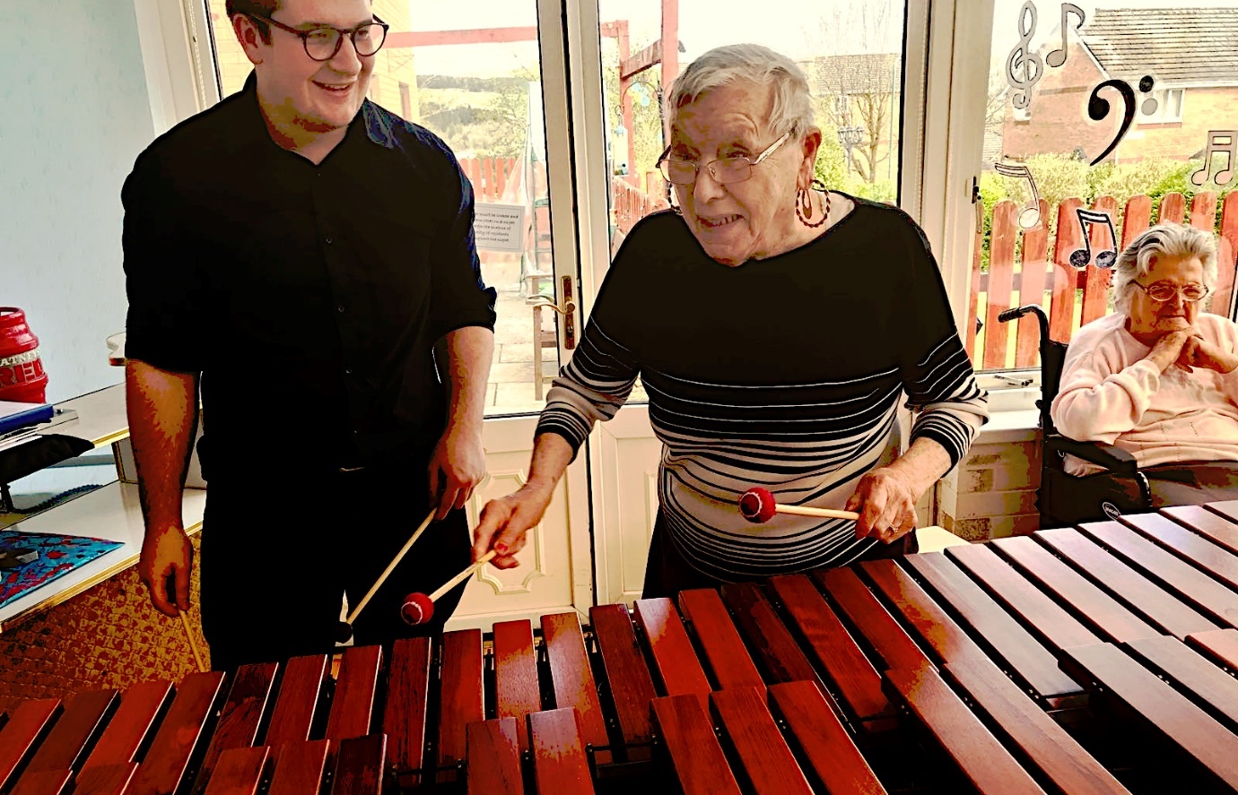

Impact on the residents, staff and setting of Woffington House
In his feedback to LMN about our sessions at the home, Adam has reported that our musicians’ visits have positively impacted on the care home’s environment and the wellbeing of its residents. He also notes that the care home has reduced the levels of sedative and PRN medication, (or pro re nata medication, i.e. medication that should be taken only as needed, for example pain medicines, sleeping pills and cough medicine), being administered to residents.

“We found when LMN were coming into the home the atmosphere would completely change. Music evokes so many different memories, but it can also be used as a prompt to bring people together.

For residents who can become anxious and agitated as a result of their underlying dementia/mental health, the intervention of live music performances has reduced their anxiety resulting in them taking part of a meaningful activity, that has promoted their wellbeing, therefore having good quality outcomes for people.

I think that the biggest impact overall that we are seeing through your input... is a 50% reduction in the use of all sedative medications being administered and 100% reduction of all PRN medication!”
- Adam Hesselden, Manager, Woffington House Care Home, Wales

The visits also had a positive impact on staff working at the care home, some of whom would stay after they had finished working to take part in LMN’s sessions.

Impact on individual residents

The LMN Wales’ musicians’ visits had a very positive impact on the life of one resident, named Tom Brown. Tom had lived in Tredegar his entire life. He married his wife when he was 25 and after she died in 2009 he moved into the care home. In his own words, without the opportunity to listen to and perform music his daily life in care consisted mostly of watching television:

“What do I do? Well I go down to the community room, you know and have a chat, watch the television. That’s the sort of life it is now isn’t it? But at 92 what else can I expect!”

During LMN’s visits they discovered Tom was a former member of the Tredegar Orpheus Choir (and in particular loved singing the Welsh song Calon Lân). He had not performed for many years since leaving the Choir but had enjoyed the live music performances from LMN at the care home. As his favourite music was traditional Welsh brass bands, the charity arranged for brass quintet Blackweir Brass to perform for him and the other residents.

In 2018 and 2019, Tom took part in the LMN Wales live music activities at Woffington House. The visits had an incredibly positive impact on his confidence, as he joined the residents’ choir to perform at the Ffrind I Mi conference in Newport, and with the encouragement of Adam gave his first ever solo performance, singing at the event at 92 years old.

Tom’s daughter Jude visited him at the care home during LMN’s performances. She commented on how much both she and her father had valued their time together during LMN’s visits, and how much it meant for him to have music back in his life again in his last few years. His performance came much to her delight, as well as that of his friends and the staff at Woffington Home – and was reported on by the local press.

Sadly, Tom passed away in September 2019, but had achieved new and unexpected heights by then through music and the partnership between Woffington House and Live Music Now.

You can watch an interview with Tom about his life, and his love for music here.

Funding and costs

Reaching a combined audience of 440 across all 20 visits, the cost of the project was £15 per participant on average.

Thank you to Arts Council Wales and the National Assembly for Wales who fund the work of Live Music Now Wales, and to LIBOR who funded the residency at Woffington House.

