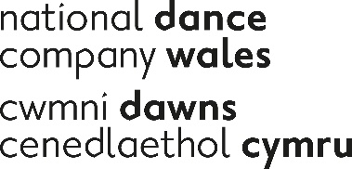

English National Ballet/National Dance Company Wales Dance for Parkinson’s Case Study

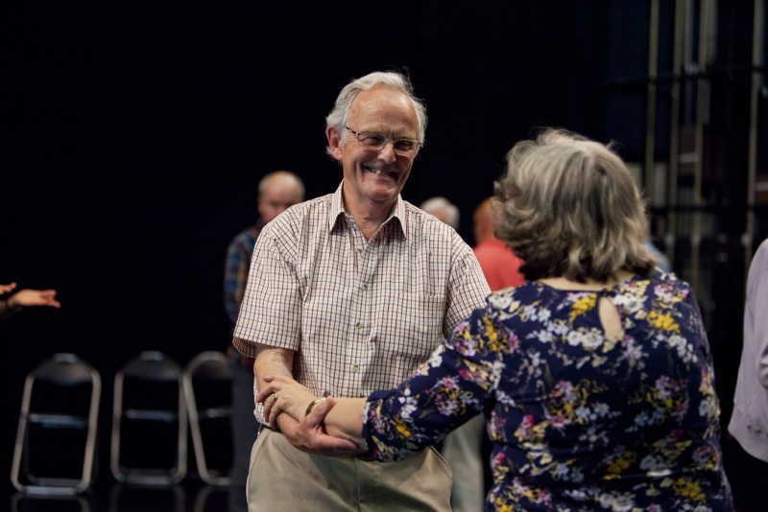
Dance for Parkinsons members during class

An overview of Dance for Parkinsons

National Dance Company Wales and English National Ballet jointly deliver Dance for Parkinsons in Dance House, Cardiff and Blackwood Miners Institute. Classes are expressive, creative and promote feelings of freedom from the physical and social constraints of having Parkinson’s.

Across the UK there are more than 120,000 people currently living with Parkinson’s, a degenerative neurological condition for which there is currently no cure.

In Wales, that figure is estimated to be around 6,000 – with the majority aged over 50. The symptoms of Parkinson’s – which can include tremor, rigidity and slowness of movement – are caused by a loss of nerve cells in the brain, lowering levels of dopamine, a neurotransmitter that plays a vital role in our physical and mental health.

However it is not known what causes these nerve cells to die.

What is known is the huge toll Parkinson’s can take, not just on the patient, but on carers like spouses and children, who in some cases even give up work as their loved one’s condition slowly deteriorates.

With Welsh citizens living longer it‘s lilkely there will be an increase of people living with Parkinsons and thefore associated costs to public bodies.

Dance for Parkinson's has been proven to support people with Parkinson’s to develop confidence and strength, whilst temporarily relieving some participants of symptoms in everyday life.

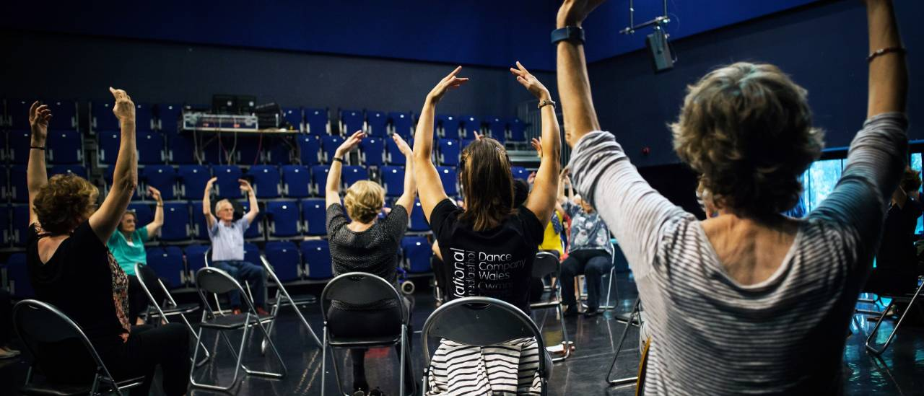
Dance for Parkinsons members during class

Research undertaken by the University of Roehampton demonstrates that dancing, as seen within the Dance for Parkinson’s project offers the benefits below :

• Aids people with Parkinson’s physically, mentally and socially
• Does not help with physical development in a uniform or linear fashion, but can help with mobility in the short term, particularly when there is musical accompaniment
• Gives participants the tools to increase body awareness and to increase confidence in order to use the mobility they have, but may not have had the courage to use
• Provides tools to help with activities in everyday life
• Gives participants the opportunity to experience different qualities and ways of moving
• Can loosen up the spinal area and help with stability and posture
• Can encourage a greater reach, focus and projection
• Precipitates feelings of well-being, determination and achievement
• Provides opportunities to create movement and stimulate the imagination

Dance for Parkinson’s, delivered in partnership with English National Ballet and NDCWales, forms the backbone of NDCWales ‘commitment to participation in dance to support health and well-being for those most in need. National Dance Company Wales exists to make excellent and engaging dance with and for all kinds of people in all kinds of places, to create new possibilities for what dance could be and for what we could be. We nurture potential where it hasn’t been recognised and develop it where it has. With movement, creativity, imagination and care, we help Wales and its diversity of people to flourish, showing/showcasing Wales in the world and the world in Wales.

ENB is a world-class ballet company, renowned for creative excellence and innovative collaborations with some of the best-known British and international choreographers, designers and creators. Bringing ballet to the widest possible audience by touring throughout the UK and beyond.

ENB’s programme is inspired by the pioneering work of Mark Morris Dance Group and Brooklyn Parkinson Group, Dance for PD®. and has been delivering its Dance for Parkinson’s programme since 2010. ENB commissioned the University of Roehampton to conduct two research studies into the benefits of dance for people with Parkinson’s, which has been published and widely disseminated for the benefit of both dance and health sectors; the results of this underpin the current programme, and can be found on the ENB website.
In 2011, ENB received funding to roll out this successful model nationally with hub partners; National Dance Company Wales in Cardiff, DanceEast in Ipswich, Merseyside Dance Initiative (MDI) in Liverpool, Oxford City Council in Oxford and Royal Albert Hall, London.

ENB/NDCW Classes

The classes for those Living with Parkinsons take place (three 8-10 week terms per year) at Blackwood Miners Institute on a Wednesday from 10 -11.15 am and at the Dance House, Wales Millenium Centre Thurdays from 2-3.15. The class costs £3.50 All classes are followed by tea and biscuits!
The ENB model and approach is inspired by the Company’s repertoire and artistic vision. The class led by an ENB Associate Dance Artist, Yvette Halfhide and Musician Helen Woods.
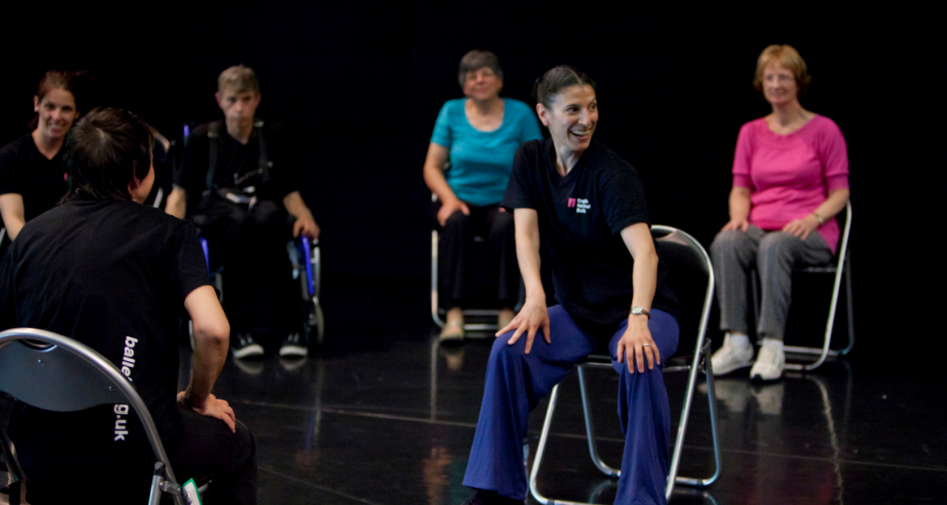
ENB Associate Dance Artist, Yvette Halfhide leading a class
Class is artistically driven, incorporating live music, dance, rhythm and voice, promoting freedom of expression. Over the last year, we have had a staggering total attendances of 1028 across both the Cardiff and Blackwood hubs combined. This figure does not include the cohort of volunteers we have recruited and trained at both venues, without whom the project would not be able to run. We hope to continue to grow these numbers with the help of Parkinson’s UK, by working with local health professionals, hospitals and hospices, and by being more of a presence in the communities we are working with.
Most recently we have been inspired by Afterimage by choreographer Fernando Melo. Afterimage formed part of the NDCWales Spring tour titled Awakening. The group that meet at Dance House have been involved in the creation of a new dance film based on Afterimage, we are looking forward to premiering the film very soon!
The benefit of class can be seen in the members quotes below

"It makes me feel I can cope better; I can walk better... it's the best medicine. I come in feeling like a little old lady", but I leave here feeling quite tall. “
Angela Harrison, Participant

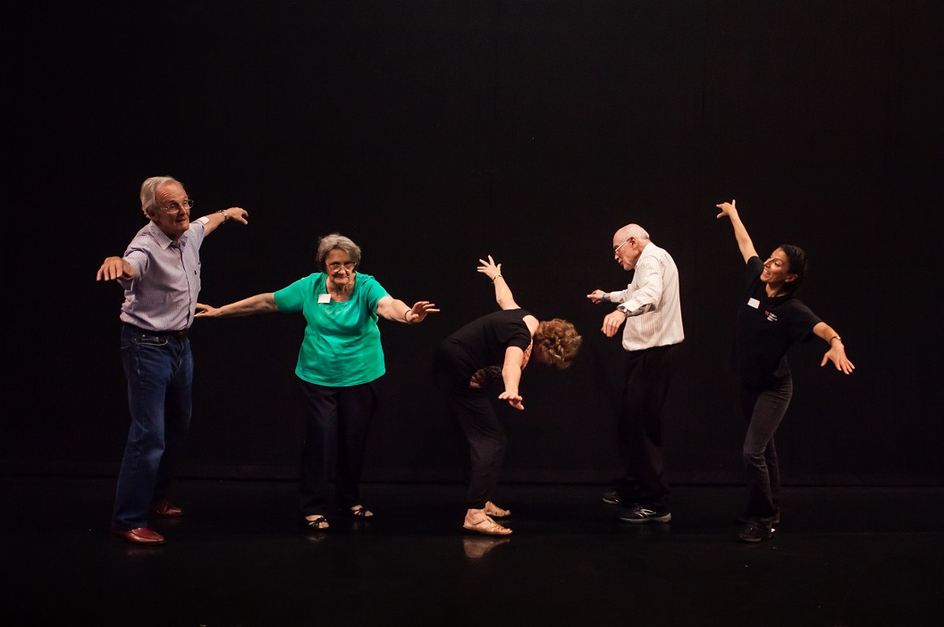
Dance for Parkinsons members during class

“…it's just having the confidence in themselves to feel that they are able to perhaps try different movements that they wouldn't have had the confidence to do beforehand. They come in perhaps with stooped posture, by the end they're much more lifted, much more open.”
Yvette Wilson, Dance Artist

“Being a volunteer for NDCWales' Dance for Parkinson's is joyful for the dancing, connecting, listening to and sharing life stories, supporting, contributing, belonging and laughing.”
Sally Varrall – Volunteer Dance for Parkinson’s Cardiff

"What a wonderful session and interesting concept for all working, living and dealing with people with Parkinson's. I am so glad I was able to attend. It inspired me to feel I would like to pursue dance more with people living with this condition."
Parkinson’s Specialist Nurse

The project has and is funded by ENB, Western Power Distribution, Caerphilly Borough Council, Moondance Foundation, Big Lottery Community Fund and The Hodge Foundation.

