Region: CARDIFF AND VALE
Touch a Flower, Talk to Me
AN INTERACTIVE TEXTILE ARTS PROJECT TO SUPPORT THE TRANSFER OF
SERVICES FROM ROOKWOOD HOSPITAL TO UNIVERSITY HOSPITAL LLANDOUGH.
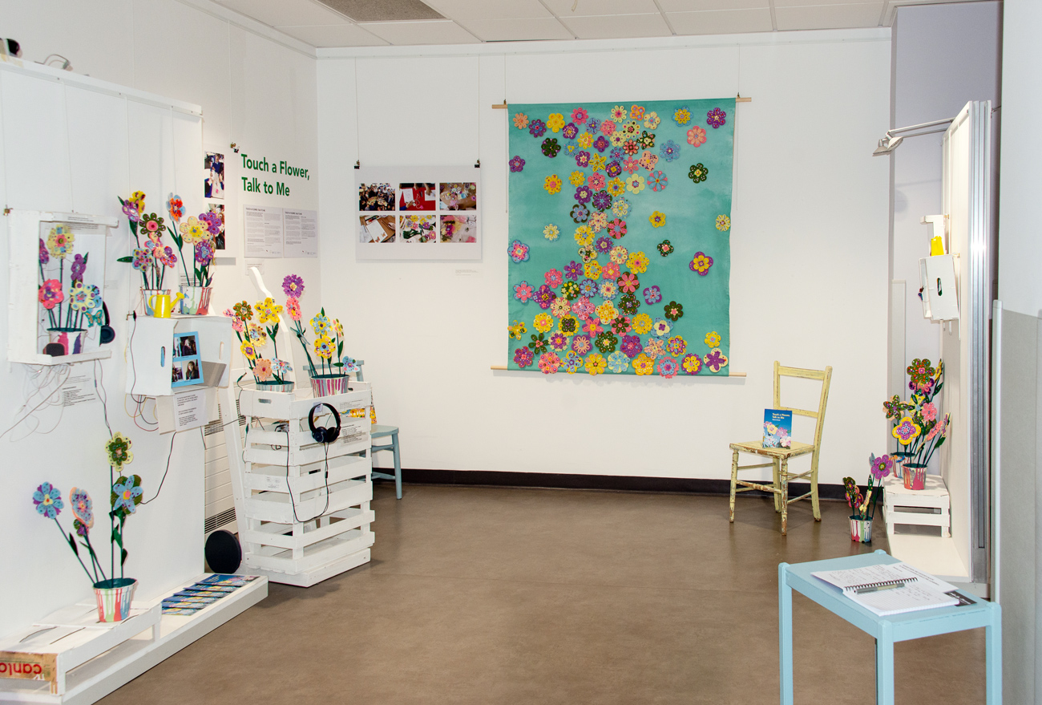
- Key Outcomes:
Staff reflected on their work and patients connected with other patients in a relaxing activity that encouraged enjoyable conversation
- Patients were proud of their achievements
- Pupils confidence in communication and problem solving skills increased
- Patients and visitors engaged well with the visual impact of the exhibition which provided a relaxing and uplifting environment outside the ward
- Artist’s professional development and opportunities for collaboration

Funded by Cardiff & Vale Health Charity and PROP appeal, this project was designed and led by artist Marion Cheung. It involved 54 participants including patients of Rookwood Hospital Specialist Neuro Rehabilitation Unit (ward 7), staff, members of Sunrise Senior Living crafts group and Year 6 pupils from Peter Lea Primary School.
After a consultation period, Marion led 8 one-hour workshops in the day room and 4 two-hour sessions in school followed by 4 weeks in July and August to construct the wallhanging and interactive display. TOUCH A FLOWER, TALK TO ME was also commissioned to provide enjoyable, relaxing activities to support patients’ recovery and rehabilitation goals; create a textile wallhanging for the day room and foster collaborative working with pupils.
A celebratory exhibition took place in September (9 - 30th) at Plaza Exhibition space, University Hospital Llandough.

During the workshops in hospital, staff invited patients to take part, supporting them with the activities alongside the artist. They decorated laser-cut flowers and painted items for the exhibition doing as much as they were able to with as much choice as possible.
“We loved it. The patients loved it...(x) was proud of her work. It was really lovely seeing everyone get involved. She was in her room and gets fed up quickly, it really cheered her up”
Healthcare support worker

To connect memories of Rookwood to Llandough, with participants’ consent, Marion carried out a series of informal interviews to discover what makes Rookwood a special place to work. Their voices were embedded into the interactive display so that visitors could touch the flowers and listen to stories of many varied career journeys. Unexpected outcomes resulted through insight into the working lives of the porters, ancillary staff, occupational therapists, registrar and chaplain. In addition to staff voices, the porters captured recordings at 5am of the birdsong, from the hospital grounds. This was added to the interactive display alongside pupils describing their involvement in the project.

Introducing the workshops to pupils, Marion engaged them in a discussion about the benefits of artwork within clinical environments and the positive effects that creative activities have on patients’ recovery. As a result, pupils were enthusiastic to get involved - gaining confidence and resilience within the problem solving activities. An estimated 1000+ visitors saw the exhibition and it attracted many positive comments, particularly from carers of patients with dementia,
“I took several patients down to the display, to my surprise even those who I imagined wouldn’t necessarily find it engaging, did. It was an incredible display of textures, sounds and colours and I was inspired by it”
Activities co-ordinator, ward E8

“What a beautiful exhibition of joy, colour, memories and history...it expresses so much of the joy and warmth that so many people feel towards Rookwood and the recordings transport you there. Looking at the flowers doesn’t make you think you’re in a hospital and the fact that you can actually touch and interact with the flowers helps that...it was an important process for many with beautiful, memorable outcomes”
Visitor, Plaza Exhibition Space, 20/09/19

Marion has enjoyed involving as many participants as possible through the project and looks forward to future collaborations within hospitals and community settings.

