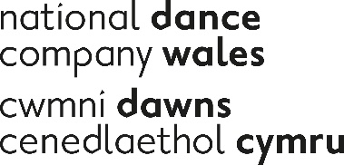

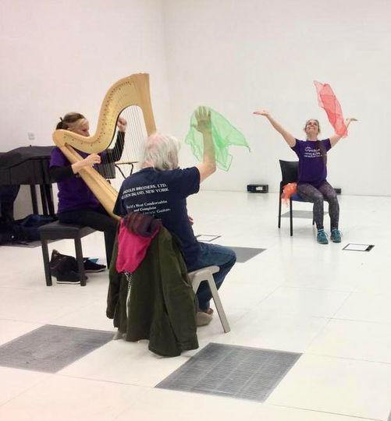
English National Ballet/National Dance Company Wales Dance for Parkinson’s Case Study

Dance for Parkinson’s class, Pontio Bangor

An overview of Dance for Parkinsons

National Dance Company Wales (NDCWales) and English National Ballet jointly deliver Dance for Parkinson‘s classes across Wales. The classes are expressive, creative and promote feelings of freedom from the physical and social constraints of having Parkinson’s. Dance Artist Angharad Harrop and Harpist Helen Wyn Pari are the NDCWales Associate Artists for the programme in North Wales. They lead the classes bilingually encorpating their knowledge of Welsh language, culture and hertiage into the programme.

Across the UK there are more than 120,000 people currently living with Parkinson’s, a degenerative neurological condition for which there is currently no cure.

In Wales, that figure is estimated to be around 6,000 – with the majority aged over 50. The symptoms of Parkinson’s – which can include tremor, rigidity and slowness of movement – are caused by a loss of nerve cells in the brain, lowering levels of dopamine, a neurotransmitter that plays a vital role in our physical and mental health.

However it is not known what causes these nerve cells to die.

What is known is the huge toll Parkinson’s can take, not just on the patient, but on carers like spouses and children, who in some cases even give up work as their loved one’s condition slowly deteriorates.

With Welsh citizens living longer it‘s likely there will be an increase of people living with Parkinsons and thefore associated costs to public bodies.

Dance for Parkinson's has been proven to support people with Parkinson’s to develop confidence and strength, whilst temporarily relieving some participants of symptoms in everyday life.

Research undertaken by the University of Roehampton demonstrates that dancing, as seen within the Dance for Parkinson’s project offers the benefits below :

• Aids people with Parkinson’s physically, mentally and socially
• Does not help with physical development in a uniform or linear fashion, but can help with mobility in the short term, particularly when there is musical accompaniment
• Gives participants the tools to increase body awareness and to increase confidence in order to use the mobility they have, but may not have had the courage to use
• Provides tools to help with activities in everyday life
• Gives participants the opportunity to experience different qualities and ways of moving
• Can loosen up the spinal area and help with stability and posture
• Can encourage a greater reach, focus and projection
• Precipitates feelings of well-being, determination and achievement
• Provides opportunities to create movement and stimulate the imagination

Dance for Parkinson’s, delivered in partnership with English National Ballet and NDCWales, forms the backbone of NDCWales ‘commitment to participation in dance to support health and well-being for those most in need. National Dance Company Wales exists to make excellent and engaging dance with and for all kinds of people in all kinds of places, to create new possibilities for what dance could be and for what we could be. We nurture potential where it hasn’t been recognised and develop it where it has. With movement, creativity, imagination and care, we help Wales and its diversity of people to flourish, showing/showcasing Wales in the world and the world in Wales.
ENB is a world-class ballet company, renowned for creative excellence and innovative collaborations with some of the best-known British and international choreographers, designers and creators. Bringing ballet to the widest possible audience by touring throughout the UK and beyond.

ENB’s programme is inspired by the pioneering work of Mark Morris Dance Group and Brooklyn Parkinson Group, Dance for PD®. and has been delivering its Dance for Parkinson’s programme since 2010. ENB commissioned the University of Roehampton to conduct two research studies into the benefits of dance for people with Parkinson’s, which has been published and widely disseminated for the benefit of both dance and health sectors; the results of this underpin the current programme, and can be found on the ENB website.
In 2011, ENB received funding to roll out this successful model nationally with hub partners; National Dance Company Wales in Cardiff, DanceEast in Ipswich, Merseyside Dance Initiative (MDI) in Liverpool, Oxford City Council in Oxford and Royal Albert Hall, London. North Wales classes began online in early 2021 moving to in person late 2021 and throughout 2022.

ENB/NDCW Classes
The ENB model and approach is inspired by the company’s repertoire and artistic vision. Classes are artistically driven, incorporating live music, dance, rhythm and voice, promoting freedom of expression. In North Wales, classes are hosted by Coleg Cambria, Wrexham and Pontio, Bangor. The Dance for Parkinson’s classes support the outreach of the venues to ensure the arts have a central role in the wellbeing of the communities of Wales. The relationships with the venues have been key in engaging participants due to the realities of starting up new classes during a pandemic.

The Winter/Spring term, saw Tamara Rojo‘s Raymonda inspire Angharad and Helen’s Dance for Parkinson’s classes. This reimagining of a classical ballet, sees Raymonda as Florence Nightingale with the ballet set during the crimean war. North Wales‘ own Betsi Cadwaladr was also a nurse in the crimea. Hailing from Bala, an area steeped in folk traditions of Wales, Ms Cadwaladr learnt to play the harp. Folk music from Wales, as well as the magnificent harp cadenza from Raymonda’s orginal score were used within the classes to explore Welsh culture. It also provided an opportunity for participants to engage with the story of Betsi Cadwaladr who lends her name to the Health Board for North Wales, through which many of the participants receive treatment for Parkinson’s.
Through working in conjuction with professionals from Betsi Cadwaladr University Health Board, the number of participants attending classes has grown, as nurses and physiotherpists who have dropped in advocate for the programme to those they work with who live with Parkinson’s.
This Spring / Summer term has seen inspiration for classes from Codi, by Anthony Matsena, which formed part of NDCWales‘ One Another Tour in Spring 2022. When creating Codi Matsena researched the history of coal mining in Wales and how the communities and culture of Wales have been shaped by it. When devising the Dance for Parkinson’s class, Angharad and Helen drew from the themes of the performance to explore how the coal, slate and granite industries of North Wales have shaped our landscapes and communities. Within the classes we explore the living folk tradition Cadi Ha, which began within coal mining communities in Bagillt, Holywell as a celebration of spring. The words of the song provide ample opportunity to play with sound and voice, helping participants to learn techniques to control the pitch, volume and speed of their speech, as we explore the constants of the Welsh Language that make up the nonsense rhyme.
During the 19th Century many miners and quarry workers would have worn clogs. The rhythm of the tune of Cadi Ha, and the steps of the dance have also provided opportunity within classes to play with the sounds and rhythms of Welsh Clog Dance. The different sounds of the steps are made with the different parts of the shoe and ideal to encourage awareness of the weights and different parts of the feet. The joyful and gleeful shouting and waving of hankies within the dance is also a great way to practice sharp and purposeful extensions of the arms. All of which help those living with Parkinson’s to manage symptoms. The living tradition of the Cadi Ha holds within it the celebration of Welsh communities to rise against the oppressive conditions of working that inspired Matsena in his creation of Codi. As we dance together within the sessions, we celebrate the richness of Welsh culture reaping the benefits of folk music and dance for our health and wellbeing. Classes end with a paned, welsh cake and good chat about all we have covered.

The project has and is funded by ENB, Arts Council Wales, Welsh Government, National Lottery Community Fund, Moondance Foundation and Pontio.
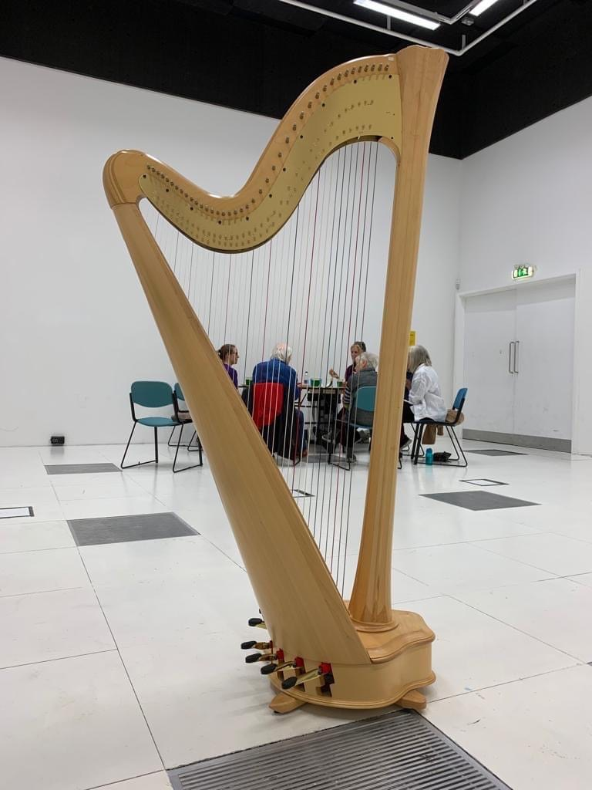
Participants enjoyed a paned and welsh cake after Dance for Parkinson’s class at Pontio, Bangor
“Bangor is the only City in Gwynedd, the heartland of the Welsh language, where over 65% of people speak Welsh. But this means so much more than language. To the people of Wales the culture and traditions are sacred, something unique that binds us together, but also something we like to share as a way to welcome people to the area. The use of the Welsh language and Welsh traditions has proved invaluable to our members at Dance for Parkinson’s with 50% of the class born and raised on these traditions and the other learning about it for the first time, you can see how it binds the members and stops language from dividing them” Mared, Arts Development Co-Ordinator, Pontio Bangor.
“I love that the sessions are bilingual, I am a Welsh learner and it’s great to have opportunities to use it socially” Participant, Dance for Parkinson’s classes, Bangor
“The Tuesday sessions are a weekly lift to body and spirit - not to mention the best homemade Welsh cakes” Participant, Dance for Parkinson’s classes, Bangor
“I have absolutely loved my Dance for Parkinson’s. I have to pinch myself sometimes because it doesn't feel real! I move more freely since the sessions, I have bought my own chiffon scarf to dance to. I can wake up in the morning, have a dance session and move so much more freely” Participant, Dance for Parkinson’s classes, Coleg Cambria, Wrexham.
“’Dawnsio Gwerin’ has long been a passion of mine and being able to bring that to the Dance for Parkinson’s sessions is a weekly reminder of how movement shapes communities, connects us to our heritage and allows us to discover more about our abilities.” Angharad, Associate Artist, National Dance Company Wales.

