The Forget-me-not Chorus
at Penylan House Care Home

30 word teaster
The Forget-me-not Chorus in care homes
The Forget-me-not Chorus aims to bring joy and meaning back into the lives of those living with and those affected by dementia through the power of song.

150 word summary
The Forget-me-not Chorus aims to bring joy and meaning back into the lives of those living with and those affected by dementia through the power of song. Through our care homes choirs we empower those impacted by dementia, their families, staff and volunteer singing buddies to share the joy of music in a safe and normalising environment, inspiring all to participate to the best of their abilities in a community of understanding. Each year we run three 12-week projects, each based on a theme and with a performance element at the end. Each Spring a project is created with a writer which enables the residents to share their life stories through poetry and song. The presence of the choir in the home offers an opportunity for all to learn about the person before dementia and gain insight into each individual resident and their ability to communicate in a nurturing environment.

Case Study (300--400 words)

Since 2014, the FMNC has run a choir in Linc Cymru’s Penylan House, Cardiff. Starting with 20 residents, the choir has expanded over the years and now runs two choirs in the home for over 45 residents, their family members and ten volunteer singing buddies . We run three twelve week projects every year, each based on a theme and with a performance element at the end. Each Spring a project is created with a writer which enables the residents to share their stories through poetry and song. The creation of the artistic performance piece encourages a creative voice as well as instilling a general sense of wellbeing and empowerment. Evaluation has shown that the experience of being a member of FMNC has a depth and strength that is more tangible than simply singing as part of a choir. The activities that take place within the FMNC encourage and build on the well-known preservation of music in the brain. Even when memories are hard to recall, music and song stimulate those memories and assist in unlocking forgotten faces and experiences.

The FMNC brings the outside world into the home for the duration of the rehearsal and the shared tea time at the end of the session. Conversations revolve around the songs that have been sung and the memories that they evoke. The buddies, families and staff encourage and share in these conversations, creating a community feeling that permeates the home for very much longer than just the rehearsal. The family members and carers of the residents are able to take part in a shared activity and experience the joy of singing with the person whom they care for, connecting once more through song.
Singing buddies are community volunteers who give their time to support a resident, encourage interaction and make sustainable and trusting relationships through the experience of singing together. As a result, the care home develops a deeper sense of community. The presence of the choir in the home offers an opportunity for care home staff to learn about the person before dementia and gain insight into each individual resident and their ability to communicate in a nurturing environment. This knowledge informs the relationship outside the rehearsal increasing job satisfaction for the staff and a more personal level of care for the resident . The project also fosters relationships between the families of the residents and the staff who care for their loved ones encouraging a cohesive and caring community with the residents at the heart.

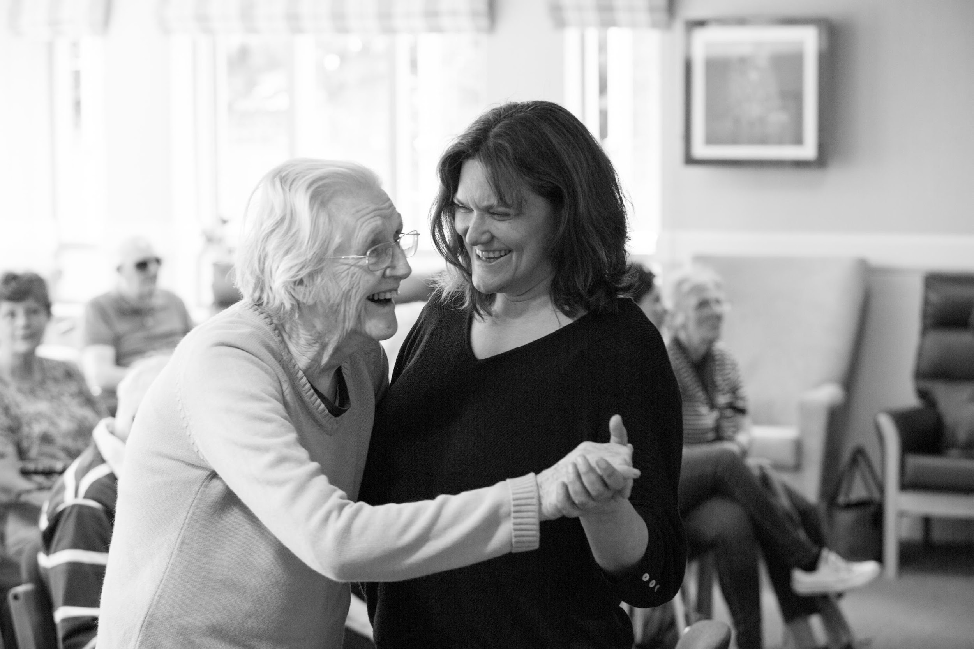

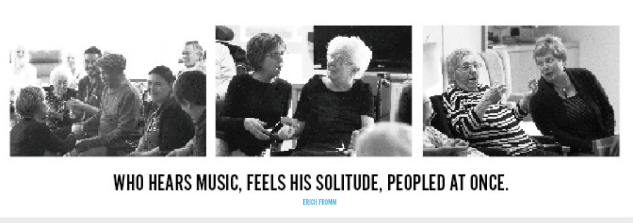

Link to a full evaluation of FMNC activity : https://drive.google.com/file/d/1HxOGMTC22Y5beJxekh250OIOpTDm2p7a/view?usp=sharing

www.forgetmenotchorus.com

