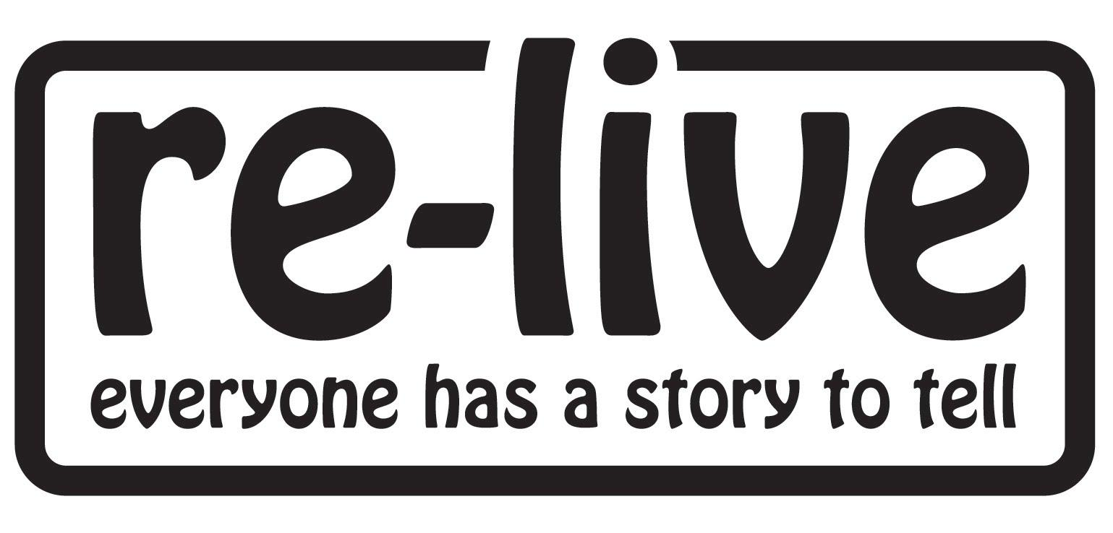
Coming Home to the Arts

"To know I have this respite is priceless, the only thing that blocks my fears and tells me I am very much alive!” Veteran’s Wife

A significant number of military veterans and family members live with post-traumatic stress, unmet mental health needs and loneliness.
Coming Home to the Arts is Re-Live's ongoing programme of arts participation with veterans, families and community members, which aims to reduce isolation, positively impact on mental health and wellbeing, and provides a bridge back to civilian life.
Partners: The Arts Council of Wales, National Museum of Wales, NHS Veterans Wales, Welsh Veterans Partnership, The Community Covenant, Chapter, The Baring Foundation.

Abandoned Brothers (2012)
Re-Live’s journey with military veterans began with a Life Story Theatre production, Abandoned Brothers. Performed by veterans and family members in Chapter Theatre, the project was awarded an Arts and Health Practice Award from the Royal Society for Public Health.
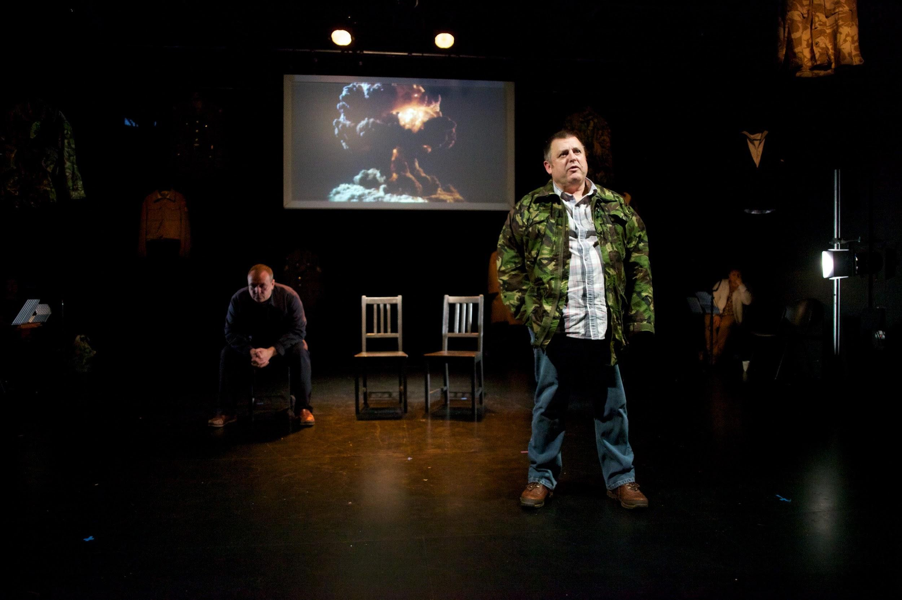
“We’ve had the chance to tell people about our lives. I feel so much better for getting it out” - Veteran Participant
Video of Abandoned Brothers can be seen here.

The Coming Home Choir (2015-)
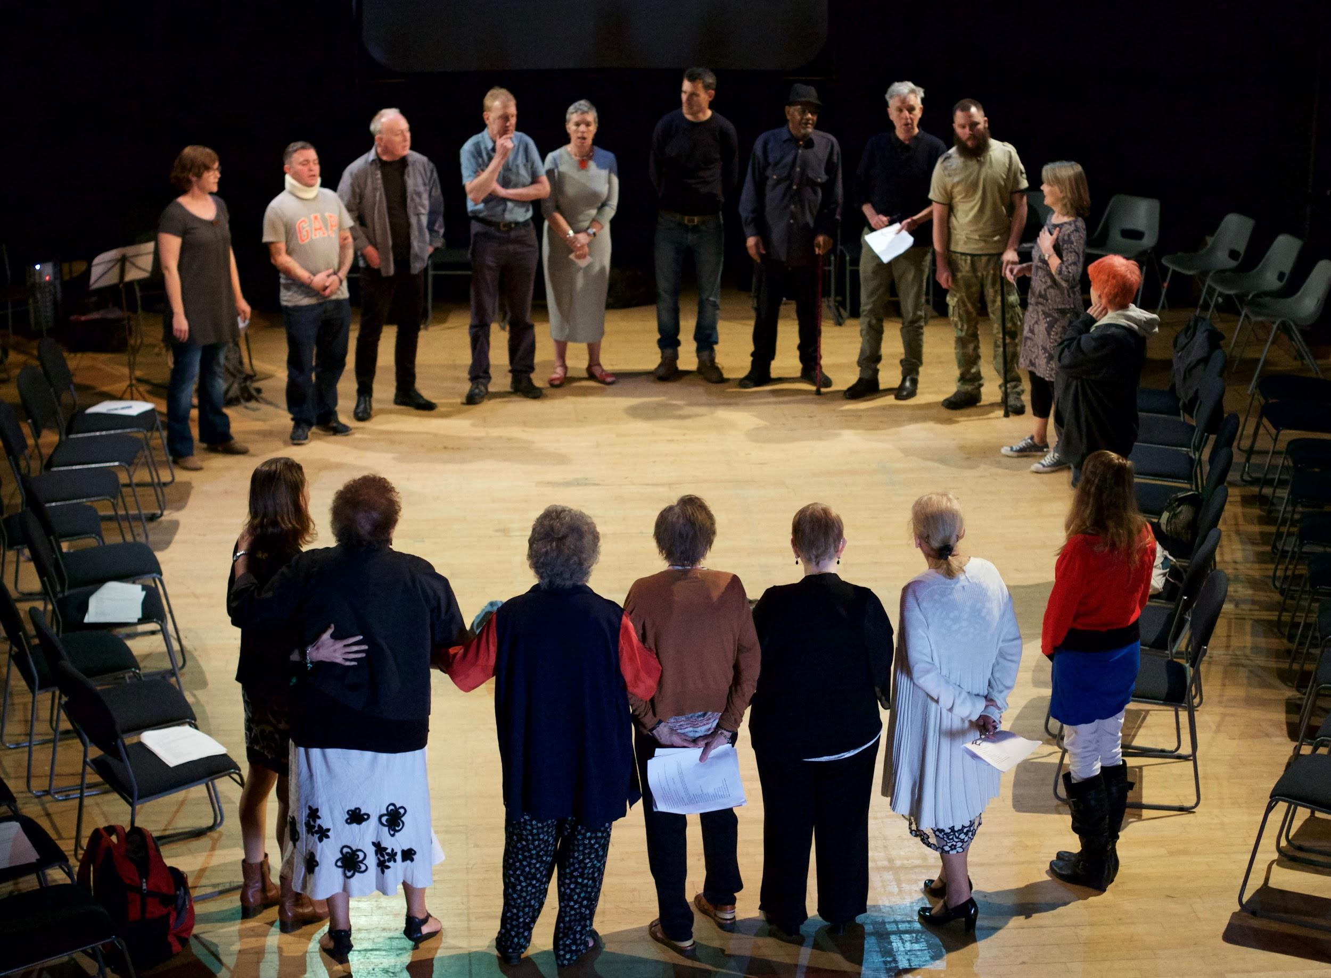
The Coming Home Choir is an uplifting and supportive place for veterans, family and community members to come together and sing.

Participants report feeling connected with parts of themselves they thought had gone forever: humour, spontaneity, fun.
“Since I left the military, I’ve been hiding away, trying to be small and quiet. Here, in this choir, I’m finally feeling like I can let it all out”- Veteran, Coming Home Choir

The choir have performed at The Welsh Mental Health Arts Festival (2017) and NHS Veterans Wales conference (2019).

Video: The Coming Home Choir perform 'Hurt'
The Return/Y Dychweliad (2019)

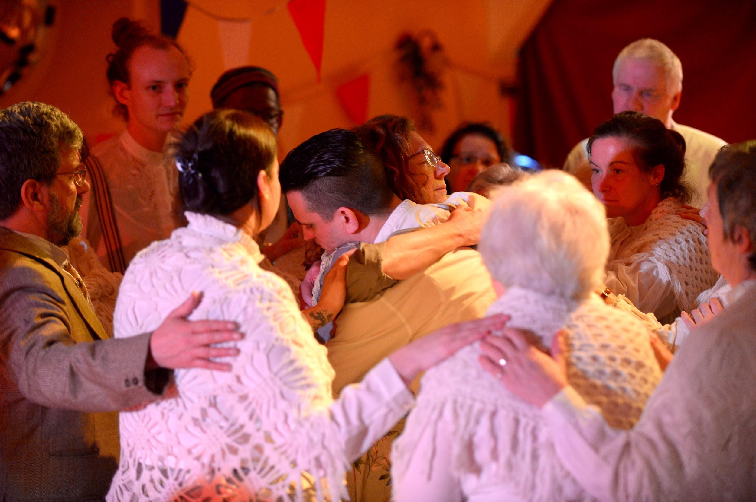

The Return/Y Dychweliad was a bilingual theatre performance at St Fagans National Museum of History, re-imagining a Victory Ball for returning WW1 veterans. It was performed by 26 veterans and families who shared their lived experiences of returning from war.

“Before The Return I was completely isolated. The show enabled me to test being around a community, let alone being in front of an audience!” Veteran Participant

Watch a short documentary about The Return here.

Coming Home To The Arts participants support one another through shared creative experiences. The work delivers benefits in terms of improved emotional wellbeing and a reduction in isolation.
In 2020, Re-Live was awarded a £70,000 Community Covenant grant to deliver a new 2-year programme of arts participation with veterans, families and community members.

Re-Live Publications:

Journal: Arts in Health: An International Journal for Research, Policy and Practice
Abandoned Brothers, Life Story Theatre with veterans and their families
https://www.tandfonline.com/doi/full/10.1080/17533015.2015.1011177
Winston Churchill Fellowship report:
Transforming Trauma: Moral Injury and Arts with Military Veterans, Families and Communities
https://www.wcmt.org.uk/fellows/reports/transforming-trauma-moral-injury-and-arts-military-veterans-families-and-communities

