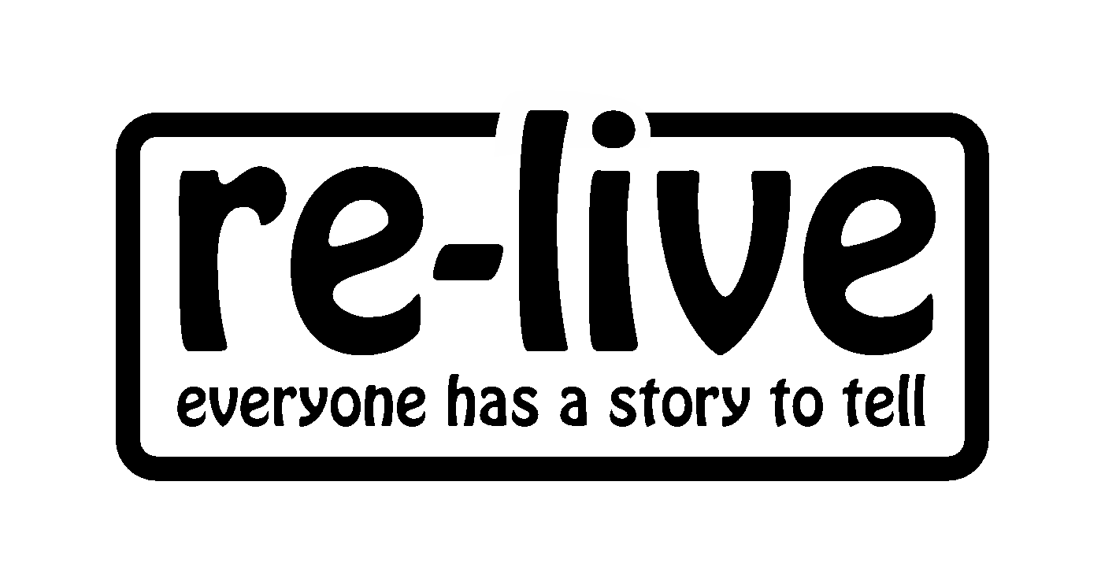

BELONGING/PERTHYN case study

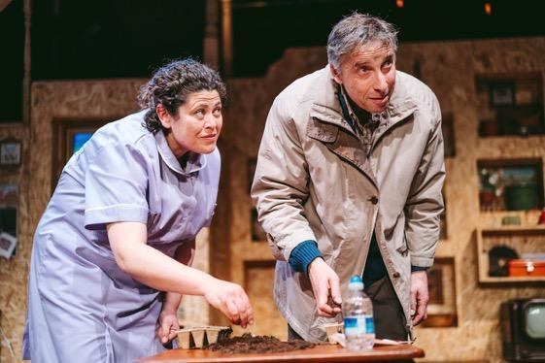
Karin Diamond & Llion Williams in Belonging/Perthyn

“There was humour and above all there was hope – not for a cure, but hope of finding meaning and closeness and human strength in the face of adversity” Professor Bob Woods, Director of Dementia Services Development Centre Wales (Bangor)

Belonging/Perthyn is an award-winning bilingual theatre play, which raises awareness and builds compassion around dementia.

The play takes a multi perspective approach, exploring issues facing people living with dementia, their families, and health and social care professionals.

The play toured theatres and arts venues in Wales in 2016 & 2018 and was performed at The Bealtaine Festival, Ireland.

Project aims:

- create a high quality theatre production which raises awareness and builds compassion around dementia
- support health and social care professionals to attend as dementia training
- offer an insight into the world of a person living with dementia and the impact on families
- address the needs of Welsh language speakers living with dementia
- demonstrate best practice in communicating with a person living with dementia
- share insight about behaviour that can be seen as challenging
- highlight the importance of knowing something about a person’s life story

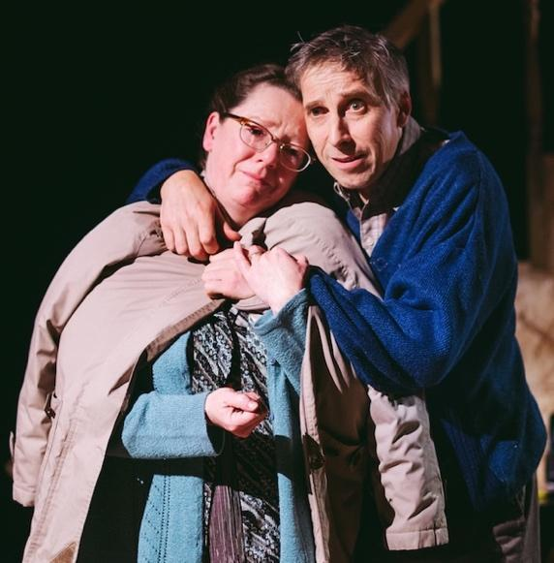

“Perfformiad gwefreiddiol drama ‘Perthyn’ heno. Potread arbenning o dementia”
Dr Elin Walker Jones

Clêr Stephens & Llion Williams in Belonging/Perthyn

Written by Karin Diamond, Artistic Director of Re-Live, Belonging/Perthyn is a creative response to:

- Re-Live’s Life Story Work with families affected by dementia – please see Memoria
- Re-Live’s experiential dementia training for health and social care professionals – please see Experiencing Dementia
- Karin’s Winston Churchill travel fellowship to Japan to research the innovative Japanese approach to dementia care with Dr Yukimi Uchide. Please see report here
- Dementia Action Plan for Wales (Welsh Government, 2018-22) here
- Good Work – A Dementia Learning and Development Framework for Wales (Public Health Wales, Social Care Wales, NHS, Welsh Government, 2016) here
- The Social Services and Wellbeing (Wales) Act 2014 here
Belonging/Perthyn received an outstanding response from audiences and critics, winning two Theatre in Wales awards (2017) for Best Director (Peter Doran) and Best Actor (Llion Williams).
Key outcomes:

- raised awareness and built compassion about dementia in communities around Wales
- Seen by 5,434 people, including over 3,000 health and social care professionals who attended a performance as dementia training
- presented an insight into the world of a person living with dementia and the impact on families through drama
- addressed the needs of Welsh language speakers living with dementia by dramatising the need to communicate in the language of their choice
- demonstrated methods of best practice in communicating with a person living with dementia
- shared insight around the causes of certain behaviours that can be seen as challenging, promoting empathy and understanding
- highlighted the importance of knowing something about a person’s life story, in order to support an individualised approach to care

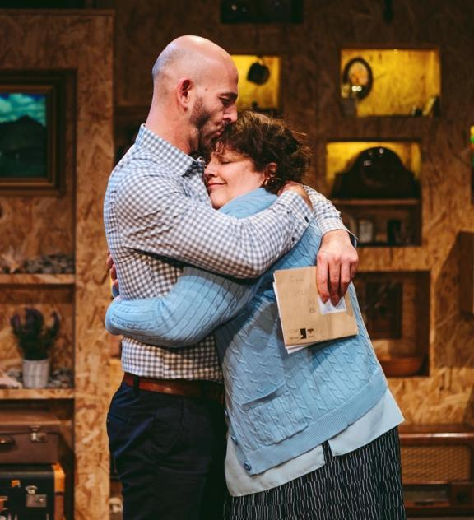

“In over 40 years of nursing, this is the best dementia training I’ve attended.” - Nurse

“It wasn’t just facts/death by PowerPoint, but engaged with all the senses and emotionally which is more long-lasting” - Occupational Therapist

Nathan Sussex & Francine Morgan in Belonging/Perthyn

Partners: The Arts Council of Wales, The Baring Foundation, Chapter, The Torch Theatre, Ageing Well in Wales, Gwanwyn, Chapter, The Bealtaine Festival, Ireland.
Cost: Funded by The Arts Council of Wales, The Baring Foundation and Re-Live: £96,111 (2016) and £81,422 (2018).
“As a student social worker I would like to thank you for teaching me so much about dementia. I've written 1000s of words on dementia, speech dysphasia, and systems theory, but today you put it all into perspective. I believe I will be a stronger, better practitioner from watching your show. So, thank you” - Student Social Worker

Future plans:
Re-Live have received numerous requests to tour the play again. They are planning a new Welsh tour in Autumn 2021 which will connect and train thousands more people throughout Wales and tour to Trinity College, Dublin and the University of California, San Francisco.

Re-Live are in discussions with theatre practitioners in Ireland and New Zealand about translating Belonging/Perthyn into the Gaelic and Maori languages.

Response from Health and Social Care Professionals here
Response from Theatre audiences here

Critical response:
'Belonging is an important piece of theatre. Beautiful and genuine’ ★★★★★
Wales Online review in full here

'Life affirming drama, entirely remarkable" ★★★★★
Buzz Magazine review in full here

British Theatre Guide review here
Theatre in Wales review here
3rd Act Critics review here
Young Critics review here

BBC Radio Cymru review by Lowri Haf Cooke here.
A feature about Belonging/Perthyn on S4C's 'Heno' here

Video response:
Ymateb aelod or gynulleidfa here
Discharge Support Officers share their thoughts here
Social Services Caerphilly Borough Council here
Two young care workers share their thoughts here
Breast Care Nurse shares her response here

Social Media trailer in English here
Social Media trailer in Welsh here

